**Lessons Learned on Course 2-Task 2 Project**

* **Did you learn anything of potential business value from this analysis?**
  + I have realized that there are more than 6600 defaulted and about 23500 not defaulted borrowers
  + Majority of the credit holders are university graduates
  + Most of the customers are Female
  + The Limit Balance for the defaulted loans is below $160,000 where as it greater than $170,000 for the non-defaulted loans
  + Majority of the age group of the credit holders is between 25 and 45

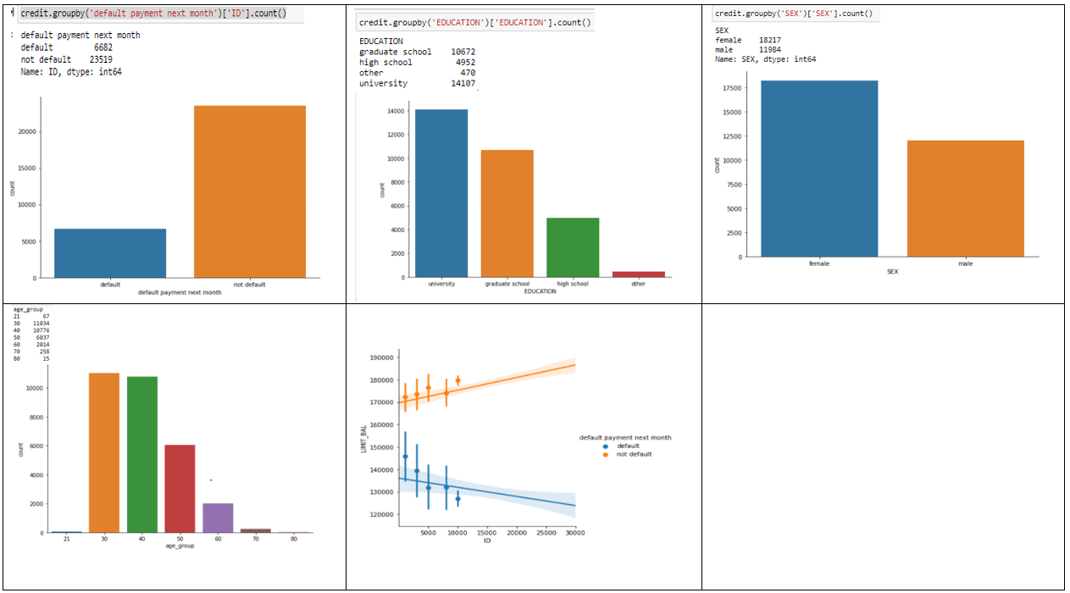

Based on the finding from the analysis

* Majority of the borrowers who have default loan are University graduates.
* Most of the borrowers who are at the age from 25-40 have default loans.
* The number of both married and single credit holders that have default loans is almost equal.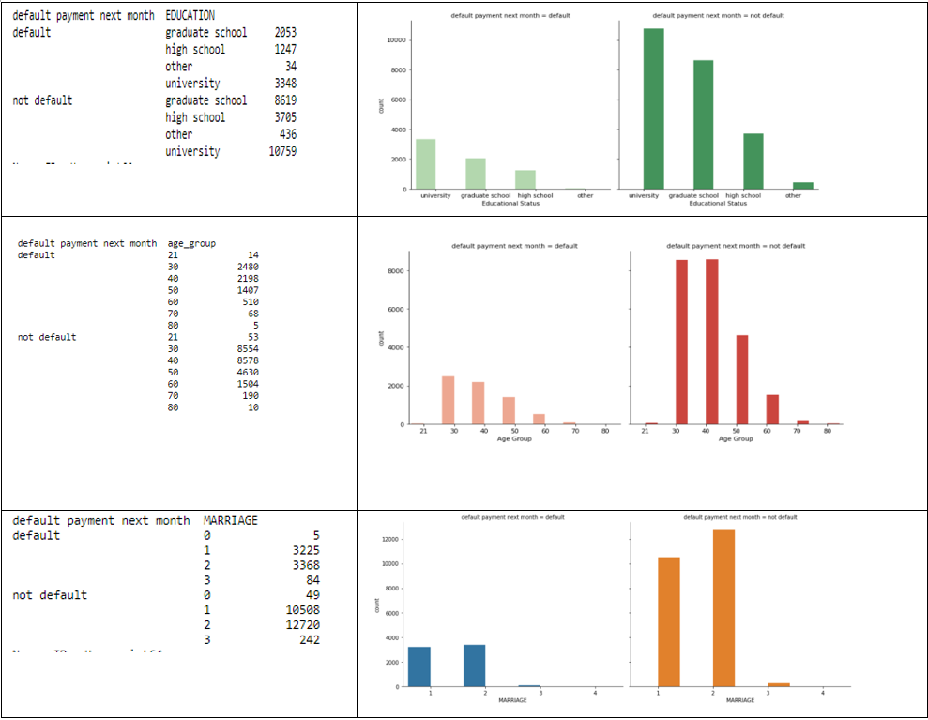
* **What are the main lessons you've learned from this experience?**
  + I have learned how to import mysql data in csv format
  + I have also learned how to clean data by identifying missing values and irrelevant data from a dataset and how to drop them.
  + Leant how to change the data type of the fields to do the analysis.
* **What recommendations would you give to the Guido regarding your findings?**
  + To minimize the LIMIT_BAL for those Credit holders who have defaulted loans
  + To categorize Credit holders as
    - Red Flag - Credit holders that fail to pay greater than 3 times
    - Yellow Flag – to those credit holders who failed to pay 1-3 times
    - Green Falg – to those who never failed to pay

So, this categorization will make CreditOne to LIMIT the balance before lending which will lead to minimize the risk of losing the business.